ShopBot

for earphones and headphones

User Guide

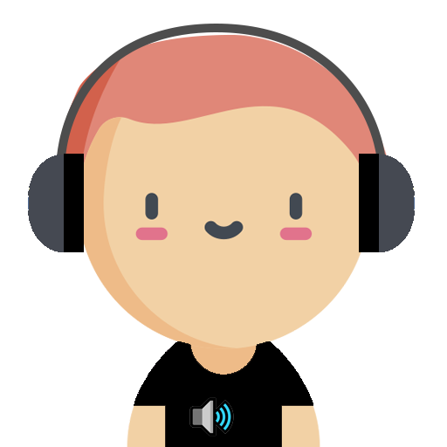

|  |  |
| --- | --- |
| **Team Members** | |
| Shashank Nigam | A0198469A |
| Lin Wenqi | A0198435R |
| Ng Mei Ying | A0198546L |
| Edmund Leow Kwong Wei  **TEAM MEMBERS**  Edmund Leow Kwong Wei  Ng Mei Ying  Wilson Lum Kok Keong A0198478A  M A S T E R O F TECH N O L O G Y  P R O J E C T R E P O RT    T E A M M E M B E R S  Edmund Leow Kwong Wei - 1  Ng Mei Ying - 2  Wilson Lum Kok Keong - 3  M A S T E R O F TECH N O L O G Y  P R O J E C T R E P O RT    T E A M M E M B E R S  Edmund Leow Kwong Wei - 1  Ng Mei Ying - 2  Wilson Lum Kok Keong - 3 | A0198458H |

Contents

**Getting Started** 1

**Quickstart on FB Messenger** 1

System Requirements 1

Installation Steps 1

**Full installation and deployment** 2

System Requirements and Dependencies 2

Pre-requisites 2

Starting RASA NLU server 2

Starting Python Flask for Webhooks 3

Importing ShopBot into DialogFlow 3

Deploying as a FB Messenger Bot 4

**Test Scenarios** 5

# **Getting Started**

## **Full installation and deployment**

Follow this section if installing and deploying to your own DialogFlow account and local web server.

### System Requirements and Dependencies

* Python or Anaconda, and Python libraries as specified in requirements.txt
* A modern web browser. Recommended Google Chrome version 76 and above.

### Pre-requisites

* Google DialogFlow account. Sign up at <https://console.dialogflow.com/>
* Kommunicate account. Sign up at <https://www.kommunicate.io/>
* Download ngrok.exe or ngrok binary to your machine from <https://ngrok.com/download>
* Clone or download project source code from GitHub repository from <https://github.com/eleow/shopBot>, and then install python project dependencies via the following script in console, optionally, in a new Anaconda environment (eg eba5004)

pip install -r requirements.txt

### Importing ShopBot into DialogFlow

* Login to DialogFlow console at <https://console.dialogflow.com/>
* Create a new agent called “ShopBot” or whatever name you desire by
  1. Clicking the cog button
  2. Clicking the “Create new agent” button

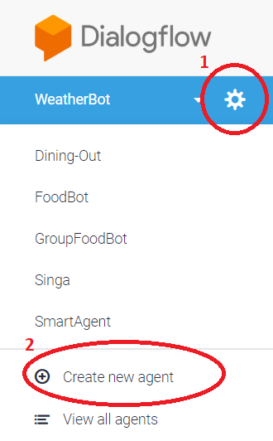

* Import the zip file (ShopBot_Deploy.zip) from the local copy of the GitHub repository at \SystemCode\DialogFlow by clicking the “Export and Import” button on DialogFlow, and then clicking “**RESTORE FROM ZIP**”

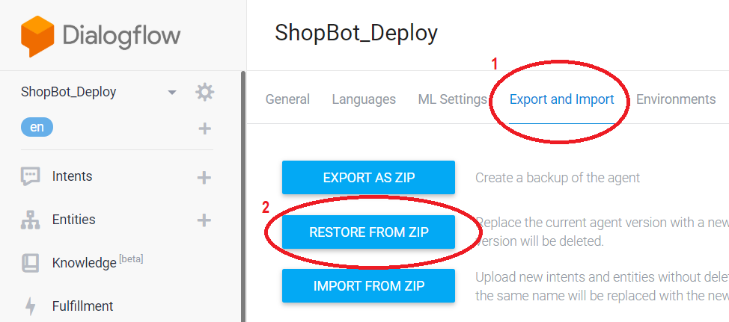

### Connecting Kommunicate with DialogFlow

* Login to [Kommunicate](https://www.kommunicate.io/)
* In [Install Page](https://dashboard.kommunicate.io/settings/install), note down your **App ID**. This will be used later

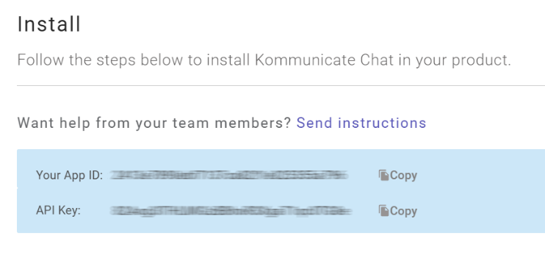

* Integrate Bot with DialogFlow in [Bot Integration Page](https://dashboard.kommunicate.io/bots/bot-integrations), by following the instructions below

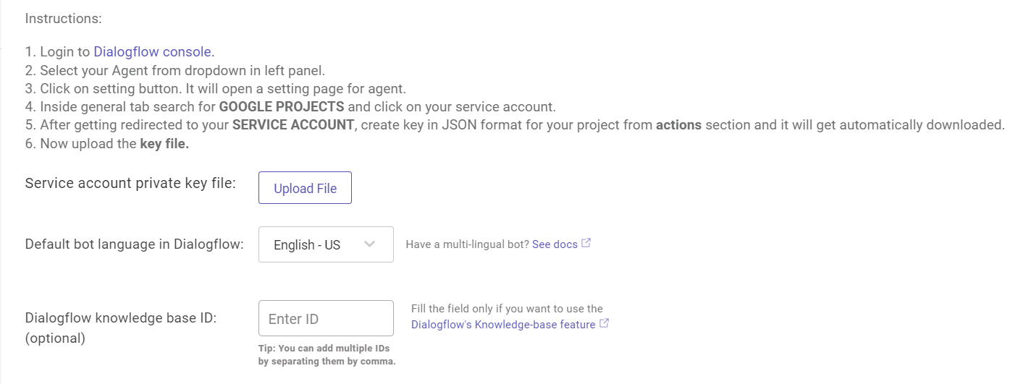

### Starting Rasa NLU server

* Navigate to the root of your local copy of the GitHub repository eg D:\github\shopBot
* Run Rasa NLU server by the following script in console:

rasa run --enable-api -m SystemCode/rasa/models/nlu_rasa.tar.gz --cors "*" -p 5015

* It might take some time to start up. But finally, you should see the following in the console

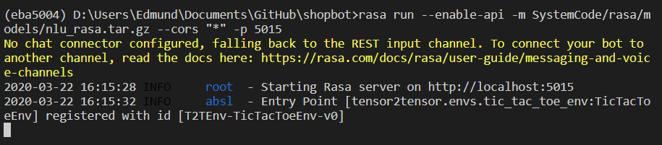

### Starting Python Flask for Webhooks

* Navigate to the root of your local copy of the GitHub repository eg D:\github\shopBot
* Run shopbot_main.py by the following script in console, using the **Kommunicate AppID** from earlier instead of <AppID>:

python ./SystemCode/Fulfillment/shopbot_main.py -s False -n True -k <AppID>

* It might take some time to start up. But finally, you should see the following in the console

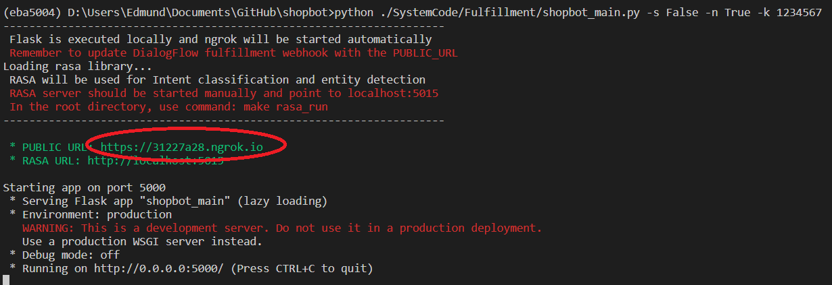

* Backend server is now running, and ngrok has been automatically started as well. Note down the public url for ngrok (Public url will change everytime you restart the backend)
* Now, we need to update DialogFlow Webhook URL with this. In DialogFlow, navigate to **Fulfilment** and configure the webhook to point to the URL that was captured earlier, and then **remember to click Save.**

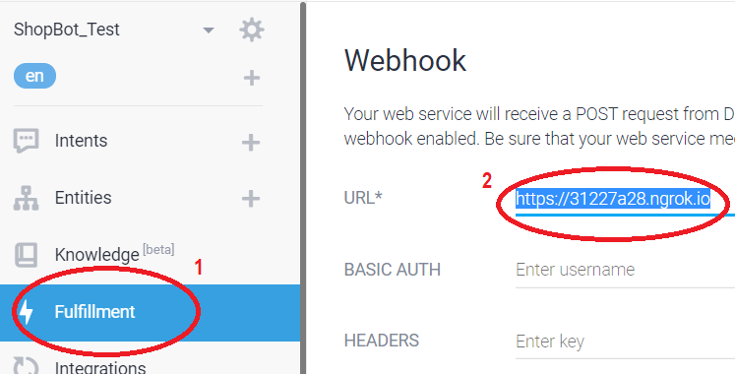

* The ShopBot is now running on DialogFlow and is connected to the local Python Flask web server through ngrok, and Kommunicate is connected to DialogFlow.

### Launching the Website

* Ensure that (i) ngrok, (ii) rasa NLU server, (iii) flask webhook are running from the steps above.
* Finally, you can launch the website using PUBLIC_URL or using <http://localhost:5000>
* Click on the AudioPhil icon  at the bottom right of the page (or any of the other items circled in red below), and start chatting!
* Note that the rest of the website will NOT work as this is just a proof-of-concept of how the chatbot could be integrated into an actual e-commerce website selling headphones.

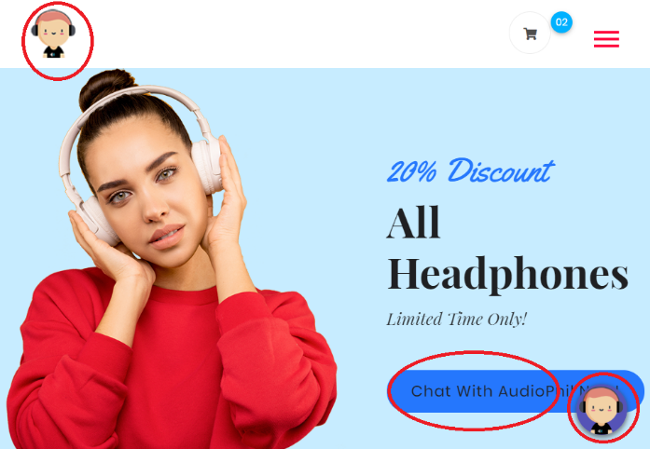

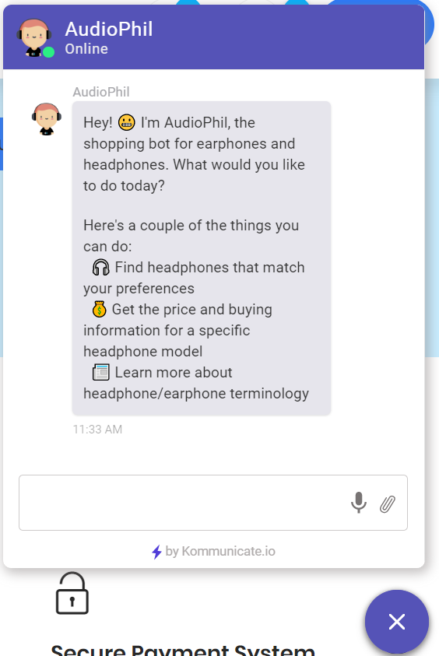

## Troubleshooting

#### [WinError 10061] No connection could be made because the target machine actively refused it

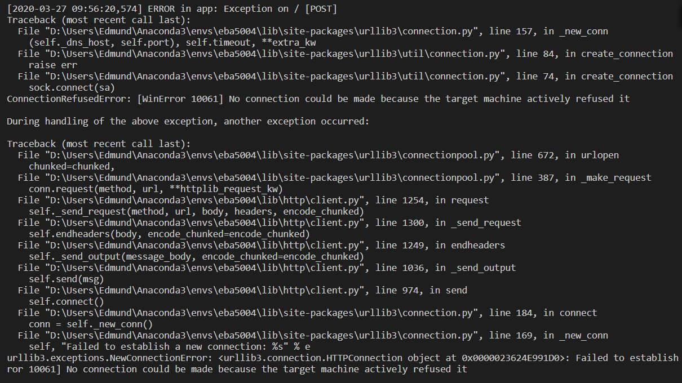

Looks like you might have forgotten to run Rasa NLU server! This error can occur if Rasa NLU server is not running or is running on a different port from what is configured. Refer to Starting RASA NLU server

## **Test Scenarios**

The following intents are available

* Welcome
* Get product recommendations
* Get pricing and buying information for a specific headphone model
* Get answers to headphone-related stuff (FAQ)

### Welcome

On launching AudioPhil, the chatbot will automatically welcome you.

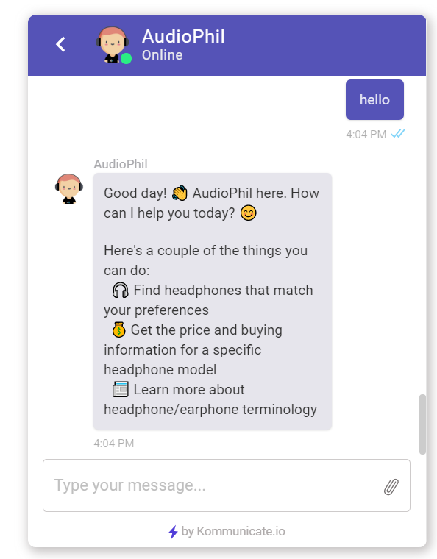

### Get Product Recommendations

TODO

### Get Pricing and Buying information

If the user provides a specific headphone model, we will provide the price and link to buy it, if it is found.

For example, “Price of AKG 452?” In this case, product is either found only in Treoo or is cheaper in Treoo, therefore, the product price and link is given from Treoo.

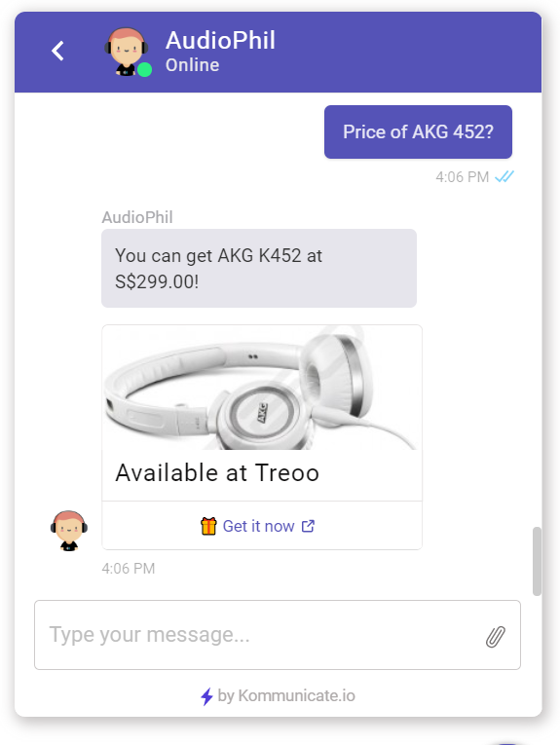

Now, we try with “price of xg13 mini”. In this case, product is found to be cheaper from Amazon SG.

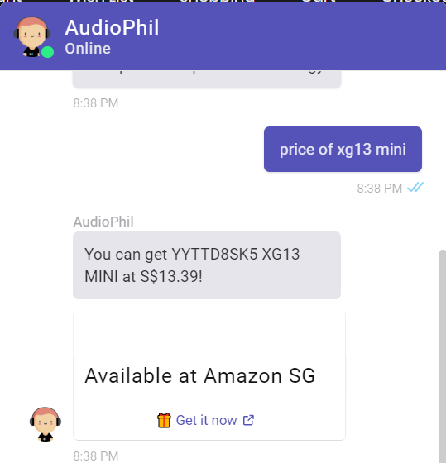

## Get answers to headphone-related stuff (FAQ)

You can ask the chatbot specific terms related to headphones. For example, “What is bluetooth?”

